**Project Design Phase-II**

**Data Flow Diagram & User Stories**

| Date | 20 October 2022 |
| --- | --- |
| Team ID | PNT2022TMID53571 |
| Project Name | Gas Leakage Monitoring & Alerting System |
| Maximum Marks | 4 Marks |

**Data Flow Diagrams:**

A Data Flow Diagram (DFD) is a traditional visual representation of the information flows within a system. A neat and clear DFD can depict the right amount of the system requirement graphically. It shows how data enters and leaves the system, what changes the information, and where data is stored.

**Example:** [**(Simplified)**](https://developer.ibm.com/patterns/visualize-unstructured-text/)

**FLOWCHART FOR GAS LEAKAGE MONITORING AND ALERTING SYSTEM**

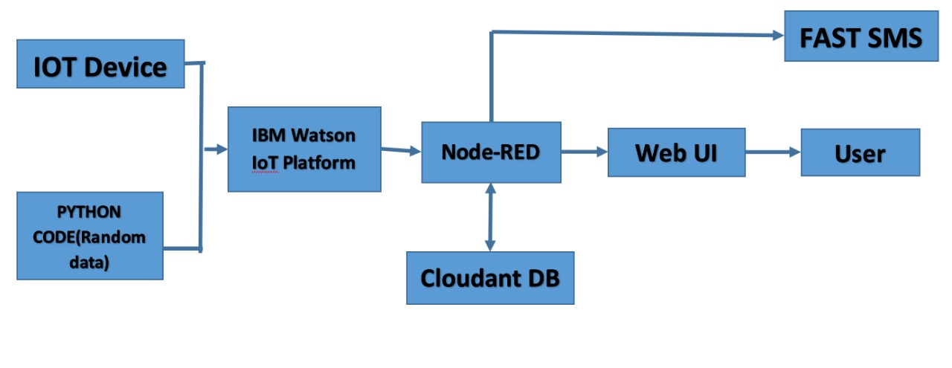

**USER STORIES AND FUNCTIONAL REQUIREMENTS**

Use the below template to list all the user stories for the product.

| **User Type** | **Functional Requirement (Epic)** | **User Story Number** | **User Story / Task** | **Acceptance criteria** | **Priority** | **Release** |
| --- | --- | --- | --- | --- | --- | --- |
| Customer (Mobile user) | Registration | USN-1 | As a user, I can register for the application by entering my email, and password, and confirming my password. | I can access my account/dashboard | High | Sprint-1 |
| Customer (Mobile user) | Registration | USN-2 | As a user, I will receive a confirmation email once I have registered for the application. | I can receive confirmation email & click confirm | High | Sprint-1 |
| Customer (Mobile user) | Registration | USN-3 | As a user, I can register for the application with nearest service provider. | Registration Process | Medium | Sprint-2 |
| Customer (Mobile user) | Registration | USN-4 | As a user, I can register for the application through Gmail. | Alternate ways to create an account | Medium | Sprint-1 |
| Customer (Mobile user) | Login | USN-5 | As a user, I can log into the application by entering email & password. | Logging into the account | High | Sprint-1 |
| Customer (Mobile user) | Dashboard | USN-6 | As a user, I can access the dashboard application by entering email & password. | Accessing the dashboard | Medium | Sprint-2 |
| Customer (Web user) | Review | USN-7 | As a user, I can provide review for the development of application within the app. | Providing review for the application | Medium | Sprint-2 |
| Customer Care Executive | Walkthrough | USN-8 | As a customer care executive, I can take down the problems faced by the customer and provide solutions. | Customer care process | High | Sprint-2 |
| Administrator | Access | USN-9 | The administrator has access for the platform and the code | Changes in the code can be done only by the admin | High | Sprint-1 |
| Administrator | Access | USN-10 | The administrator should provide the admin access to the develop in order to update the application. | Without admin access, the acode of the application cannot be accessed | medium | Sprint-1 |